SAP Business ByDesign Implementation

Project “All-in-1”

BRD Document
Submitted To



By



SAP Business ByDesign BRD Report – Document Specifics

Project: | “All – in – 1 “
Client: | Yamato Transport (S) Pte. Ltd
ERP- SI: | Web Synergies Pte Ltd
Created By: | Siddhartha Goswami & Debasish Choudhury | Date: 12/05/2023
Verified By: | Vishal Jha | Date: 12/05/2023
Version: | V 1.1

(This page is intentionally left blank)
Contents

1. EXISTING ORGANIZATIONAL STRUCTURE: 5
1.1 HEAD OFFICE 6
1.2 LINE OF BUSINESSES 6
1.3 NON-BUSINESS 8
1.4 REGIONAL HEADQUARTERS 8
2. EXPECTATIONS FROM SAP BUSINESS BYDESIGN 9
3. SRM ( Purchasing & Inventory ) : 10
3.1 AS – IS Process: 10
2.1.1. Packaging Material Procurement: 11
2.1.2. Consumable Material Procurement: 12
2.1.3. Service Procurement: 13
2.1.4. Asset Procurement: 15
2.1.5. Master Data: 16
3.2 Expectations from the system : 17
4. CRM ( Sales ) : 18
4.1 AS – IS Process: 18
3.1.1. Overseas Relocations: 18
3.1.2. GD Forwarding: 20
3.1.3. Logistic: 21
3.1.4. Last Mile Solutions: 22
4.2 Expectations from the system : 23
5. Finance: 25
5.1 CHART OF ACCOUNT: 25
5.2 GENERAL LEDGER : 25
5.3 ACCOUNTS PAYBLE : 26
5.4 ACCOUNTS RECIEVABLE : 27
5.5 BANK ACCOUNTING & CASH ACCOUNTING : 28
5.6 ASSET ACCOUNTING 29
5.7 Expectation from system 30
6. Defined Organizational Structure 33
7. Limitation / Dependency 34
8. Reports Requirement 34

EXISTING ORGANIZATIONAL STRUCTURE:
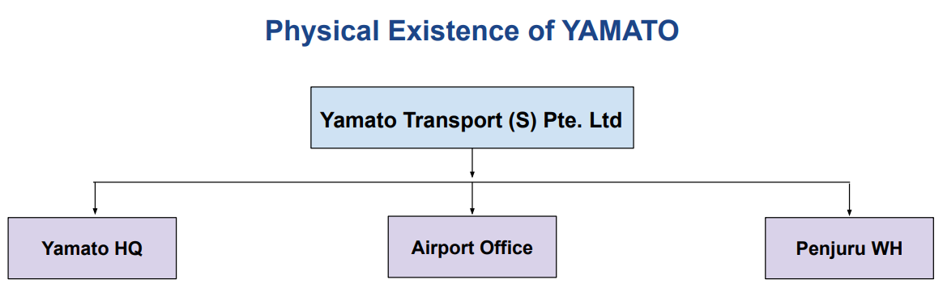
Finacial structure :
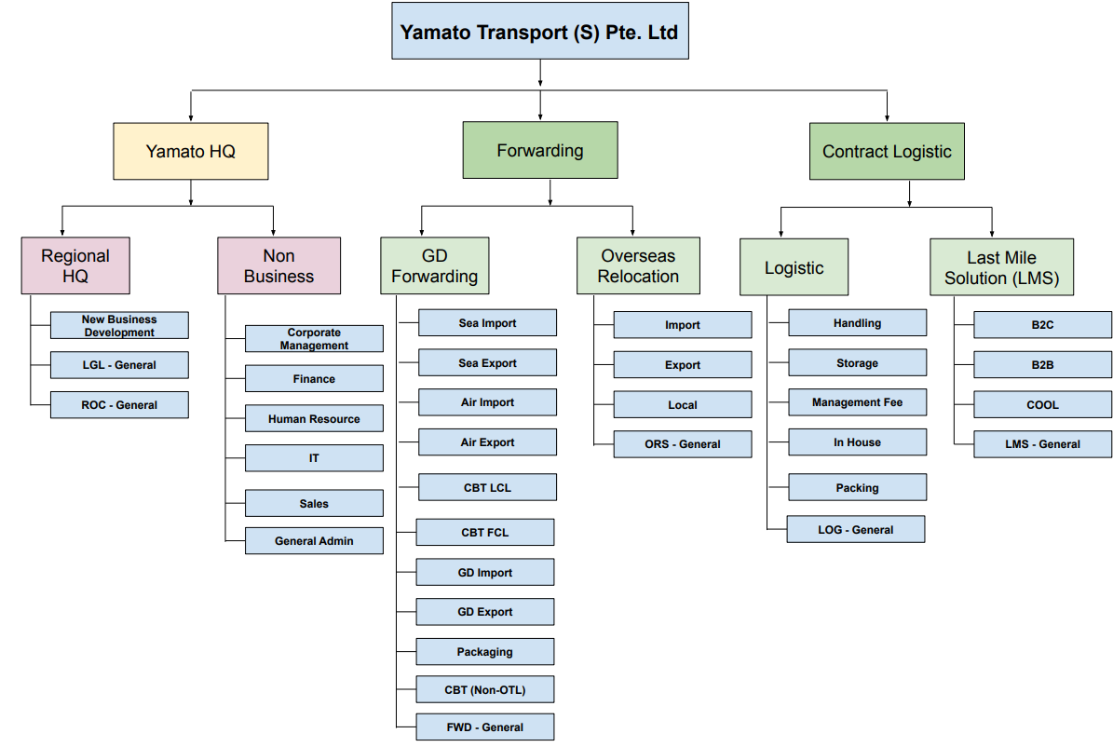

  - HEAD OFFICE

- At present scenario, Yamato had HQ located in Singapore since 1983. Currently Yamato Singapore had 4 Line of Business – GD Forwarding, Overseas Relocation (ORS), Logistic & Last Mile Solutions.
- Under Yamato HQ, consist of two units – Regional HQ & Non-Business.
- Regional HQ consists of – NBD General, LGL General & ROC General which basically work coordinately with the operation & legal team. Regional HQ is controlled by Yamato Japan.
- Non-Business is regarded as the department of Yamato HQ consisting of – Corporate Management, Finance, Human Resources, IT & Sales.
- Yamato HQ prepares the annual budget for each line of business.
- Consolidate Profit & Loss Statements, for each line of business will be generated at HQ level.
- Budget expenditure will be tracked monthly wise for each line of business from the HQ level.
- All the payments – incoming & outgoing are done centrally from HQ.
- The GST Tax Filing is done centrally from HQ consisting of all 4 business units.
- The Cash Flow – Direct & Indirect will be maintained in HQ.
- The balance Sheet will be generated from the HQ level.

  - LINE OF BUSINESSES
Currently in Yamato Singapore, there are 4 line of business which are briefly explain below –

- GD Forwarding – GD forwarding categorized under the forwarding segment. Individual P/L statement is generated from the GD forwarding business unit. Below-mentioned are the business element of GD forwarding -
- Sea Import
- Sea Export
- Air Import
- Air Export
- CBT LCL
- CBT FCL
- GD Import
- GD Export
- Packaging
- CBT (Non-OTL)
- FWD- General

- Overseas Relocation Service (ORS) – ORS is also categorized under the forwarding segment. Individual P/L statement is generated from the ORS business unit. Below-mentioned are the business element of ORS –
- Import
- Export
- Local
- ORS - General

- Logistics – The Logistics business unit is categorized under Contract Logistics, and the P/L statement is generated accordingly. Below-mentioned are the business element of Logistics –
- Handling
- Storage
- Management Fee
- In House
- Packing
- LOG – General

- Last Mile Solutions – The last mile solutions business unit is categorized under Contract Logistics, and the P/L statement is generated accordingly. Below mentioned are the business element of last-mile solutions –
- B2C
- B2B
- COOL
- LMS – General

NON-BUSINESS

In the present scenario, the non-business unit is categorized only as the department of Yamato Singapore where cost allocation & cost distribution activities are carried. All the costing reports need to be generated by Department wise.

The below-mentioned are the department under the non-business unit category-

- Corporate Management
- Finance
- Human Resource
- IT
- Sales

REGIONAL HEADQUARTERS

The Regional Headquarters unit is controlled by Yamato Japan, and they formed to help or work coordinately with all the business units of Yamato Singapore or outside Singapore regards to new business development, operations & legal team activities. All the costs incurred under the regional headquarters will be charged back to Yamato Japan.

The below-mentioned are the unit element under the regional headquarters category –

- New Business Development
- Regional Legal
- Reginal Operational Coordination

EXPECTATIONS FROM SAP BUSINESS BYDESIGN

- In SAP Business ByDesign, the Balance Sheet need to generate at the Yamato company code level.
- The Cashflow statement – Direct & Indirect to be generated at the Yamato company code level.
- Yamato HQ, Forwarding and Contract Logistics need to be categorized as Segments in SAP.
- All 4 business units are to be considered as Business Residence, Profit Center Group & Cost Center Group.
- All the business elements under each business unit will be treated as Profit Center & Cost Center as per their activity.
- Individual Profit & Loss Statement to be generated from Business Unit level.
- Sales Organization to be considered on 5 business units – Regional HQ, GD Forwarding, Overseas Relocation Services (ORS), Logistics & Last Mile Solutions.
- Purchasing Unit to be considered on 6 business units – Regional HQ, Non-Business, GD Forwarding, Overseas Relocation Services (ORS), Logistics & Last Mile Solutions.
- Business Residence to be considered on 4 business units & Regional HQ, Non-Business as well.

- SRM ( Purchasing & Inventory ) :

  - AS – IS Process:

Currently Yamato Singapore is following the mentioned procurement processes:

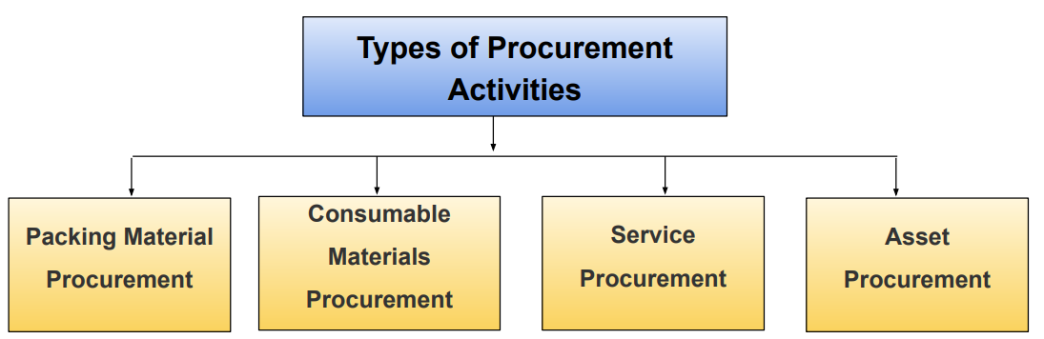

2.1.1. Packaging Material Procurement:

The current packaging material procurement cycle is as follows:

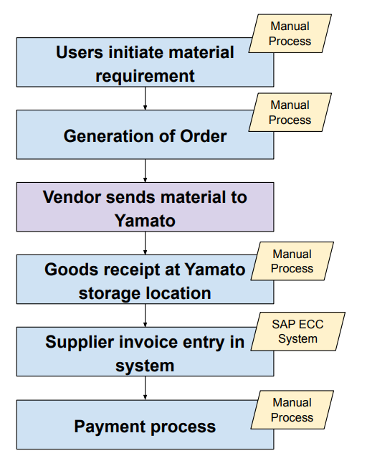

- The material procurement cycle starts with the generation of requirement i.e. PR followed by the order (currently PR / PO is same for Yamato) then goods receipt and once GR is done, Invoice entry.
- Approval process is applicable for purchase order and the approval strategy is as follows:

- Below 500 SGD – Department HOD to approve.
- 500 to 25 K SGD – Deputy MD to approve.
- More than 25k SGD – MD to approve.

2.1.2. Consumable Material Procurement:

The current consumable material procurement cycle is as follows:
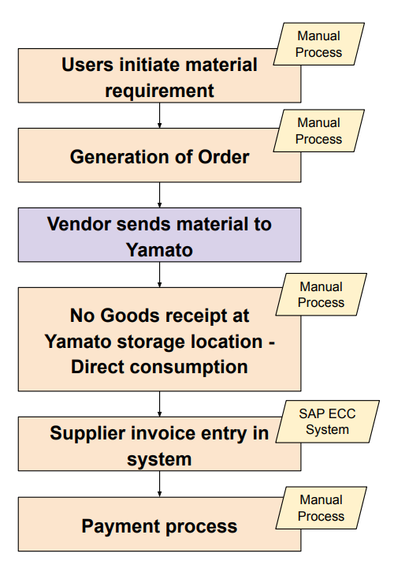

- The material procurement cycle starts with the generation of requirement i.e. PR followed by the order (currently PR / PO is same for Yamato) then goods receipt and once GR is done, Invoice entry.
- Approval process is applicable for purchase order and the approval strategy is as follows:

- Below 500 SGD – Department HOD to approve.
- 500 to 25 K SGD – Deputy MD to approve.
- More than 25k SGD – MD to approve.

2.1.3. Service Procurement:

The current service procurement cycle is as follows:
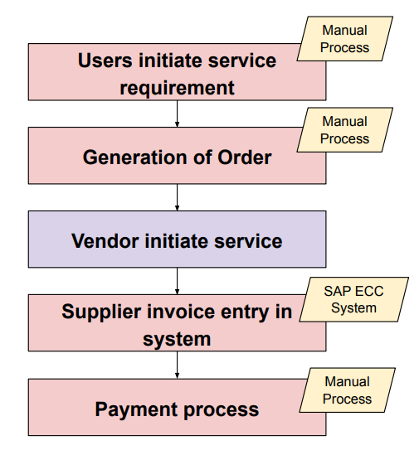
- For service purchase, cycle starts with generation of requirement i.e. PR followed by the order (currently PR / PO is same for Yamato ) once service is completed, Invoice entry and finally payment.
- Quotation process is followed in cases of service procurement wherever applicable.
- The import procurement process is applicable only for Service Purchases.
- Approval process is applicable for purchase orders and the approval strategy is as follows:

- Below 500 SGD – Department HOD to approve.
- 500 to 25 K SGD – Deputy MD to approve.
- More than 25k SGD – MD to approve.

(This page is intentionally left blank)

2.1.4. Asset Procurement:
The current asset procurement cycle is as follows:
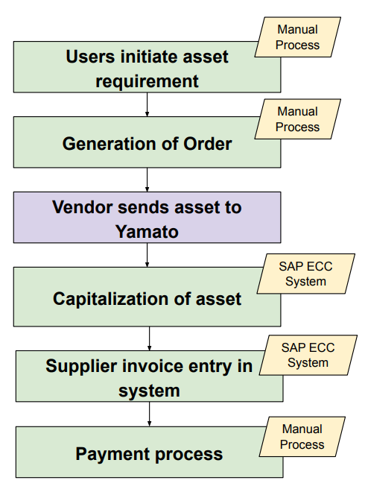

- The asset procurement cycle starts with the generation of requirements i.e. PR followed by the order (currently PR / PO is same for Yamato) then asset capitalization followed by Invoice entry & payment process.
- Approval process is applicable for purchase order and the approval strategy is as follows:
- Below 500 SGD – Department HOD to approve.
- 500 to 25 K SGD – Deputy MD to approve.
- More than 25k SGD – MD to approve.

2.1.5. Master Data:

- Material Master:

- Material code is currently external, and Yamato is following alpha numeric nomenclature.
- Currently material master is created vendor wise and based on ordered quantities.
- Material master is currently maintained in an in-house software ( Kintone).
- A material master contains details like Record number, product type, product code, product name, product UOM, product minimum order quantity, product price, and product vendor.
- Unit conversion is currently not maintained in Yamato (eg: ordered qty UOM- KG & issuing qty UOM – GM)
- Carton box is the only salable material for Yamato currently.

- Vendor Master:

- The vendor code is currently internal.
- It is currently being maintained in the ECC system.
- Currently, multiple vendors are created branch-wise with the same name.
- A vendor master contains details like Company Code, Vendor code, Search term, Reconciliation account, House No, City, District, Postal code, Telephone number and terms of payment.

  - Expectations from the system :

- The purchase order is required to be generated from the new SAP system.
- The purchase request function needs to be activated, however not to make it mandatory for all purchase order.
- The purchase RFQ (request for quotation) function needs to be activated, however not to make it mandatory for all purchase order. YAMATO may used this function for Service purchases in few scenarios.
- Blanket PO functionality needs to be activated in the new SAP system.
- Material master database is required to be maintained in the new SAP system.
- Internal number range nomenclature is required to be maintained.
- Vendor masters should be maintained in the new SAP system and provision is required for multiple number ranges based on vendor group.
- Consumable materials should also have the goods receipt function in the new SAP system.
- Option for asset capitalization process after billing process.

(This page is intentionally left blank)

- CRM ( Sales ) :

  - AS – IS Process:

Currently Yamato Singapore is following the mentioned sales processes, which can also be referred to as line of businesses:

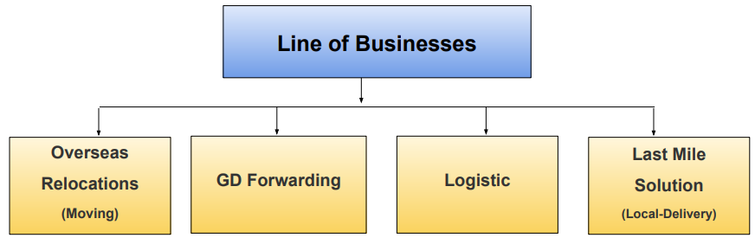

3.1.1. Overseas Relocations:

- Overseas relocation segment can be categorized into two types:
- Local (Domestic)
- Overseas
- Overseas can be further segregated by Inward Operation & Export Operation.
- For Local(domestic) category the process starts with incoming enquiry > survey > quotation > billing>payment process.
- For overseas operations (Inward), the process starts with incoming enquiry > survey > quotation > billing>payment process. However, for inward-moving jobs, Yamato’s other country entities will be responsible for the entire operation apart from the Port to Door delivery operation. Accordingly Yamato Singapore will bill to Yamato other entity for delivery charges.
- For overseas operations (Outbound), the process starts with incoming enquiry > survey > quotation > pickup ( packing/lifting/preparation of shipping instruction, etc.> handover of shipping instruction to forwarding department> container booking > shipping > billing>payment process.
- For outbound moving jobs Yamato have three types of quotation:
- Door to Door (FHD)
- Door to Port (DPP)
- All charge collect (ACC)
- Currently the forwarding department raises the bill to the moving department for the involvement of forwarding activities.
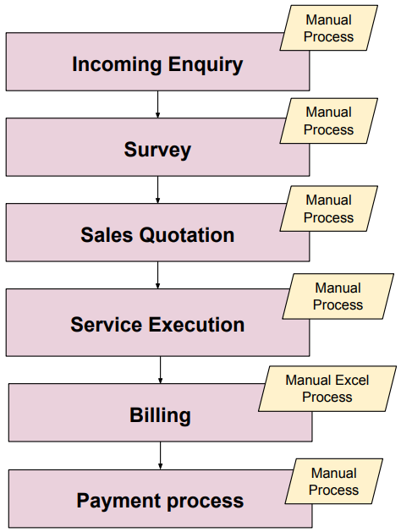

3.1.2. GD Forwarding:

- GD Forwarding operations process starts with incoming enquiry > review customer request > checking of rates availability > raise quotation > quote accepted > circulate quote to various department/overseas offices>follow-up for shipment > develop new businesses>shipment confirmed>billing.
- The GD Import and GD Export process operations are the same as mentioned above for the GD forwarding segment. However, conditions in a quotation may vary.
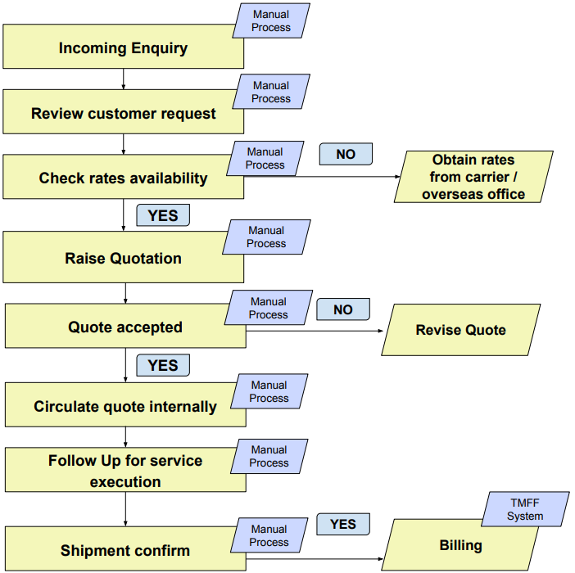

3.1.3. Logistic:

- The process starts with incoming enquiry followed by reviewing of enquiry > quotation to customer > acknowledging quotation by customer > sharing quotation internally to departments > job execution > billing by customer logistic team.
- Logistic segment works on businesses like local distribution, storage, inbound, outbound, delivery, export, etc.
- For import shipments forwarding segment has intra role with logistic segment.
- Pricing/tariff depends on multiple conditions like size of parcel/pallet/container or type of container service etc.
- For few customers contracts are also applicable and generally contracts are valid for 2 years.
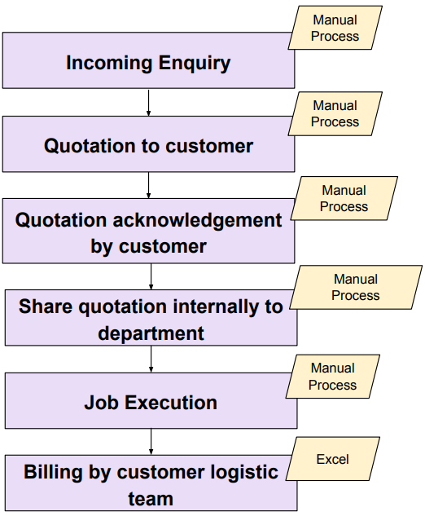

3.1.4. Last Mile Solutions:

- Under the local delivery segment there are mainly two categories:
- Overseas local delivery
- Local delivery door to door
- Local delivery can be further segregated by B2C & B2B.
- The business process starts with an incoming enquiry followed by a review of the enquiry > Sharing information to the LMS team > LMS team prepares suggested selling rate > Sales team provide a quotation to the customer > Quotation acknowledgement from the customer> Sharing quotation internally with the LMS team > Job execution > Billing.
- Quotation rate can be derived job-wise or parcel-wise.
- Tarif rate is determined by (Net Cost + Markup).

(This page is intentionally left blank)

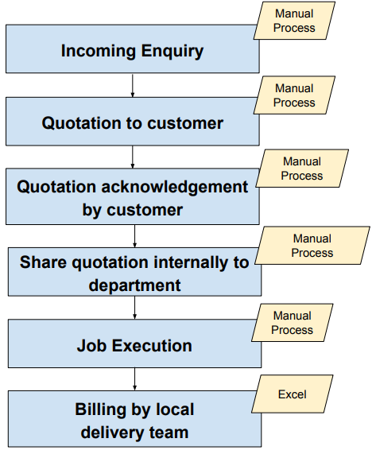

  - Expectations from the system:

- The sales order is required to be generated from the new SAP system.
- Opportunity process is required to be mapped in the sales cycle for capturing details like opportunity category, Yamato sales strategy, Lead stage, etc. which can be further linked with sales force system.
- The sales quote process is required to be followed in the new SAP system.
- Multiple customer group’s function needs to be activated in new SAP system & accordingly multiple number ranges are required as per customer groups.
- SO upload function is required in SAP system.
- Amendment/Editing function for existing SO.
- SO approval process may be required to be configured at the time of UAT.
- Price list function is required in the SAP system.
- Need to activate the credit limit function in the new SAP system while creating sales order.
- Multiple payment terms functions are required.

(This page is intentionally left blank)

- Finance :

  - CHART OF ACCOUNT:

- Presently Yamato Singapore are using one Chart of Account in SAP ECC, under which Profit & Loss statement, Balance Sheet & Cashflow statement are defined.
- Most of the Account Group & GL’s account are being maintained from Yamato Japan accordingly.
- All the sub-ledger under account group is maintained to view the report by sub-ledger wise.
- 1 legal entity is incorporated into the SAP system, where the P/L, B/S & cash flow is generated.
- Currently, there are 4 business units in Yamato Singapore, where the P/L statement is generated, and consolidation of the P/L statement are done between the business units.
- Currently, the trial balance is generated from SAP ECC on company code level.

  - GENERAL LEDGER:

- In current scenario, Yamato Singapore prepared the GL’s account under respective Account Group in SAP ECC. There is currently one chart of account (COA) where all GL’s account is maintained.
- Currently, the P/L, B/S and cashflow statement is prepared in Excel by Yamato Finance user.
- GL’s account posting for all the relevant invoices, payments, and accrual entries are done.
- Trial Balance is generated from SAP ECC at Yamato HQ level, where all GL’s balances are extracted to prepare the relevant reports in Excel.

  - ACCOUNTS PAYABLE:

PROCURE TO PAY:

- In current scenario, purchase requisition is not created in Yamato HQ.
- Each Head of Department raises the request as per the requirement of the respective department.
- Once the purchase of goods/services is fixed from a vendor, Yamato users will mail their requirements to the concerned vendor and confirmation of purchase will be taken by mail itself.
- Invoice Receipt is done manually by the Finance Department. If any surplus or deficit in Invoice receipt or Goods Receipt is settled through Debit Note and Credit Note.
- After verification of invoice receipts, it moves to the Finance Department for approval for payment.
- If, any advance payment is processed to a certain vendor that advance payment and the remaining payment need to be adjusted.
- GST part will be captured in the vendor tax invoice.
- Payment is processed through an online transfer & cheque to the vendor’s respective bank account.

OUTGOING PAYMENT:

- The outgoing payment to the vendor is done at Yamato HQ by Finance Department after verification of the invoice.
- Currently, advance payment is carried out typically for the customs agencies for clearance of goods at the port.
- Deposits (cheques) need to be passed to condominium managements to get permissions of relocation, especially for ORS.
- The payment is done through an online transfer or cheque to the vendor.
- All the outgoing payments are approved by the Finance Department and, either MD or DMD (1 Finance Leader and 1 management).
- Currently all the payments are processed & clear one-by-one vendor-wise in SAP ECC.
- Regional HQ expenses are charged back to Yamato Japan.
- Payment terms and timings are manually controlled.

  - ACCOUNTS RECIEVABLE:

ORDER TO CASH:

- In current situation, Yamato Singapore start capturing the opportunity in Salesforce software for Global accounts. For local accounts, they maintained the opportunity database in Excel format manually.
- Once the opportunity is confirmed, Yamato Singapore gives the sale quotation to the customer comprises of service details, expected delivery date, rates, etc. Once the sale quotation is accepted by the customer, the job execution is taken placed accordingly to the operation team under different business units. If not accepted, sales may need to revise quotation(s) and retry.
- Sales quotations had different service items and rates as per 4 business units.
- Once the job is done by the operation team, the invoice will be raised from the concerned business unit to the customer.
- As of now, there are no consolidated customer invoice functionalities in Yamato. Hence, they prepared all the customer invoices in Excel & TMFF.
- Before raising the sales quotation to the customer Yamato will check the credit limit. If it’s a new customer, the credit limit application form needs to be fill-up by the customer before job execution.
- In the customer invoices, GST is captured.

INCOMING PAYMENT:

- All the incoming payments are received centrally in Yamato HQ Singapore.
- In current scenario, Multiple payment terms are created as per customer / customer group wise.
- If any customer failed to pay the payment within the payment term, there credit limit will get affected from next time.

  - BANK ACCOUNTING & CASH ACCOUNTING:

BANK ACCOUNTING:

- Presently all the incoming payments and outgoing payments are done through Yamato HQ Bank Accounts.
- Collected Revenue is deposited into receiving bank account in Yamato HQ.
- Bank Payment is done online and by cheque.
- Currently, Bank Reconciliation is done manually by Finance Department through the SAP ECC system. In the process, Yamato Finance Department Check Bank statements and SAP General Ledger Balance to reconcile.
- Employee’s expenses are reimbursed by Yamato HQ through bank transfer on monthly basis.

CASH ACCOUNTING:

- Cash sales transactions are incurred for the ORS & forwarding airport business unit. All the transactions are captured in SAP ECC currently by Yamato Singapore.
- All the petty cash transaction are done centrally from Singapore HQ.

  - ASSET ACCOUNTING

- For procurement of any asset the concerned department or business unit user may also request the quotation in the email if there is no specific vendor available in the database of Yamato.
- Once the order is placed to the specific vendor upon the approval of HOD and/or DMD and/or MD (depending on amount total).
- Goods receipt is done manually by the concerned Department or business unit user.
- Vendor invoice verification is done by Finance Department in Yamato HQ.
- After verification of the invoice, the payment is processed after getting approval from the Finance department, and either MD or DMD (1 Finance Leader & 1 Management).
- In the current scenario, asset depreciation is run monthly on the booked value on the SLM method considering the residual value in SAP ECC.
- Currently, impairment processes are done for fixed assets & ROU assets yearly.
- In the ROU assets, the depreciation method SLM is used & useful lives are determined by length of contracts.
- Currently, Yamato Singapore doesn’t have a CIP/AUC asset in SAP ECC.
- Currently asset scrap is disposed completely by Finance team. Additionally, some assets are scrapped / disposed through customer sales order.

  - Tax Management

- GST is categorized under Input and Output Tax.
- Currently, in SAP ECC only one GL’s is created for GST.
- Currently, in FY 2023 8% & 0% GST rate is maintained for Input and Output. Last year it was 7%.
- For purchasing & selling 2nd hand cars, the GST rate will be half of the current GST rate.

  - Expectation from system – General Ledger Accounting

- In SAP ByD, the P/L statement should be generated from the business unit level which will be marked as Profit Center group. Consolidated P/L statement to be generated for business units.
- 2 Chart of Account i.e., Statutory & Managerial COA to be prepared in SAP ByD.
- 1 Chart of Depreciation to be maintained in SAP ByD where all the fixed assets & relevant data – depreciation method & residual values are to be captured.
- All the GL accounts should be unified under a specific account group in SAP ByD. The number ranges of GL accounts should be system generated or even Yamato can create in externally.
- Account group to be created under financial statement for both Statutory & Managerial COA in SAP ByD.
- The Cash Journal functionality is to be scoped in SAP ByD for Petty Cash transactions.
- The GST run monthly & yearly to be executed from SAP ByD.
- The BRS functionality is to be scoped in SAP ByD.
- GL posting uploader functionality is to be enabled in SAP ByD.
- Cost Center report to be generated from respective Cost Center Group & Cost Center in SAP ByD.
- Each Profit Center should generate P/L statements in SAP ByD.
- Cost allocation and Cost Distribution transactions to be executed in SAP ByD between different Cost Center.
- Annual Budgeting functionality to be scoped in SAP ByD.
- Month-end closing & Year-end closing activities (closing cockpit) need to be executed in SAP ByD.
- Month-end period open & close functionality to be enabled in SAP ByD.
- Reversal of entries functionality to be enabled.
- Recurring entries functionality (journal vouchers, invoices, etc.) to be scoped in SAP ByD.
- Audit trail functionality to be enabled.
- Direct AR/AP posting is to be allowed.
- GL’s account posting is to be allowed.
- GL’s account code is to be restricted to 7 digits in SAP ByD.
- Excel template to be provided for uploading AP, AR & SO transactions.
- Profit Centre Code is to be restricted to 3 alphabet characters & Cost Centre Code is to be restricted to 5 numeric digits. The first letter should represent for types of Accounts (= Ranges).
- Auto-reversal.
- Attach document function, if available.
- Reversal Entry / Reset function.
- Bulk-import function should be all or nothing (All posted successfully, or All failed together).
- Dashboard enabled.
- FX Revaluation run with Details for each line item.
- Intercompany Confirmation, only if possible.

  - Expectation from system – Tax Management

- GST reports to be generated and GST Run functionality to be enabled in SAP ByD.
- GSTR Run will be executed for GSTR Input and Output report.
- From 2024, new GST rate 9%Receipt / Payment advice may be sent for some customers / vendors
- For some countries, Withholding Tax is applicable – Withholding Tax posting / report need to be supported.
- The GST run monthly, quarterly & yearly to be executed from SAP ByD.

  - Expectation from system – Fixed Asset Accounting

- 1 Chart of Depreciation to be maintained in SAP ByD where all the fixed assets & relevant data – depreciation method & residual values are to be captured.
- Fixed Asset & ROU assets impairment process to be done in SAP ByD.
- Fixed asset classes with depreciation method (SLM) & residual value need to be maintained in SAP ByD.
- Fixed Asset / ROU master creation functionality to be enabled in SAP ByD.
- CIP/AUC functionality to be enabled in SAP ByD.
- Fixed Asset & ROU asset disposal processed to be mapped in SAP ByD.
- Assets transfer functionality to be enabled in SAP ByD.
- Asset depreciation to be calculated automatically in SAP ByD.
- Depreciation run to be executed for both COA – Statutory & Managerial.
- Asset register to be generated from SAP ByD.
- Cost allocation and Cost Distribution transactions to be executed in SAP ByD between different Cost Center and GL.
- Fixed Asset impairment / revaluation.
- Attach document function, if available.

  - Expectation from system – Account Payable

- Expense GLs for Intercompany accounts need to have Trading Partner field.
- Vendor reconciliation account to be mapped one-on-one with vendor account group in SAP ByD.
- Ageing report for vendor to be generated from SAP ByD.
- Purchase Order report will be executed weekly.
- Attach document function, if available.
- Purchasing Requisition needs to be approved by Purchasing Head.
- Purchasing Order needs to be approved via criteria (Cost Centre GM / DMD / MD rule will be applied).
- GR/IR run to be executed at month-end in SAP ByD.
- SAP ByD needs to export Payment run information in a specific format to be read by Standard Charted Bank H2H system (Host-to-Host system).
- PO needs to be tagged to SO or PO needs to be tagged to Customer whenever applicable (May need to have a field to key in Customer name or code always).
- One PO may contain several items to be approved by different GMs (For instance, uniform orders in bulk can be done by Logistics and LMS divisions at the same time. In this case, PO may need to be reviewed by both Logistics and LMS GMs).
- CSV or XML export (for Standard Chartered Bank auto-processing).
- Direct AR posting is to be allowed.

  - Expectation from system – Account Receivable

- Direct AR posting is to be allowed.
- Quotation can have 2nd page for T&C
- Invoice information needs to be exported in either xml, json, csv, xls or xlsx
- Consolidated Invoice.
- Sales return / damaged parcel.
- Interface information with Salesforce (Integration is done by Yamato side).
- Customer reconciliation account to be mapped one-on-one with customer account group in SAP ByD.
- Ageing report for customer to be generated from SAP ByD.
- Revenue Recognition run to be executed on the Customer Invoice level.
- Credit Limit for customer as well as Credit Limit check on SO level functionality to be scoped in SAP ByD.
- Dunning function to be scoped in SAP ByD.
- Consolidated Invoice functionality.
- Attach document function, if available.
- Defined Organizational Structure

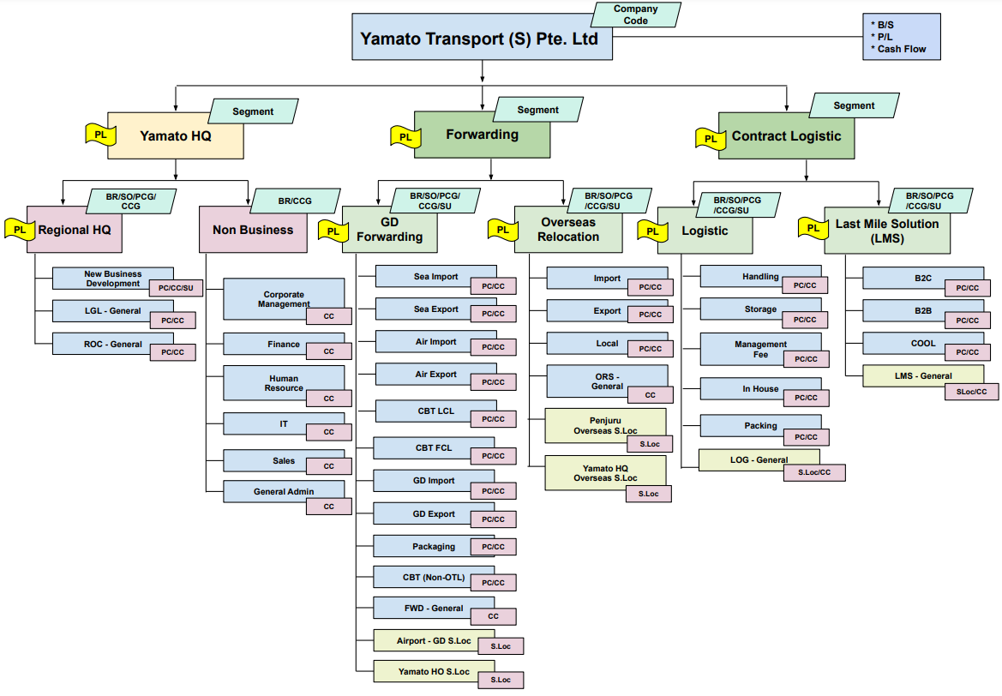

- Limitation / Dependency

- Blanket PO transaction is not a part of the SAP ByD standard function however will be checking in the system for a workaround.
- Customer number ranges (Business Partner) as per customer account group need to be checked with SAP.
- Vendor number ranges (Business Partner) as per vendor account group need to be checked with SAP.
- Approval Matrix as per Yamato Singapore needs to be customized in SAP ByD.
- ROU assets discounted rate calculation processed to be checked with SAP, but a workaround solution can be suggested.
- Integration with DMS system (for delivery) if required will be taken care in next phase.
- Integration with Infolog system(for logistic) if required will be taken care in next phase.
- Integration with CargoWise system(for forwarding) if required will be taken care in next phase.

- Reports Requirement

- Aging (AP / AR)
- P/L for business Unit
- Revenue report – Customer wise
- Investment Report (for actual & forecast)
- Weekly Forecast report
- GP report – (listing up all SO # & PC & Customer & Sales & Expense & GP for one specific month with Size or Lane, if applicable).
- Weekly update report – listing up all current opportunities and its stage including Global accounts on SFA + local only accounts not on SFA.
- Car mileage report – listing up all car mileage expenses.
- Personal Income Tax report for expats.

Sign-Off: -

____________________________________________

